Power Quality Conditioner with Series-Parallel Compensation Applied to Single-Phase Systems

ABSTRACT
This paper deals with compensation algorithm schemes used in single-phase Unified Power Quality Conditioner (UPQC), allowing harmonic suppression and sag/swell compensation of the input voltage. In addition, reactive power compensation and harmonic suppression of the input current are also carried out, resulting in an effective power factor correction. Two different operation modes are employed to control the UPQC using Synchronous Reference Frame (SRF) based controllers. In the first mode the series converter acts as a sinusoidal current source, while the parallel converter acts as a sinusoidal voltage source. In the second mode, the series converter acts as a non-sinusoidal voltage source, while the parallel converter acts as a non sinusoidal current source. A comparative analysis of the two operation modes is made, in which the advantages and disadvantages of each are discussed. Validation results are presented to confirm the theoretical development and performance of the single-phase UPQC.
In this project, a single-phase UPQC is implemented, which is composed of two single-phase full bridge PWM converters to perform the series and parallel active power line filter functions. The single-phase UPQC will be implemented adopting two different operation modes. In the first mode, the series converter works as a sinusoidal current source, while the parallel converter also works as a sinusoidal voltage source. In the second mode, the series converter works as a non-sinusoidal voltage source, eliminating utility voltage disturbances, while the parallel converter works as a non-sinusoidal current source eliminating any current harmonics injected from non-linear loads into the power supply system.
In both operation modes the output voltage regulation is considered, resulting in output voltage with constant rms value and lower Total Harmonic Distortion (THD). In order to extract the single-phase current and voltage compensation references, necessary to compensate the input current and the output voltage, Synchronous Reference Frame (SRF) based controllers are used, in which were adapted to be used for single-phase loads.

The coordinates of the unit vector$\sin{θ}$ and$\cos{θ}$, used in SRF-based controllers, are obtained from the single-phase Phase-Locked Loop (PLL) system. A comparative analysis of the two operation modes used to control the UPQC is made, in which their advantages and disadvantages are discussed. The sinusoidal and non-sinusoidal characteristics of the voltage and current references generated by the SRF-based controllers are considered. Finally, validation results are presented to confirm the theoretical development of the single-phase UPQC.
Block diagram for proposed system
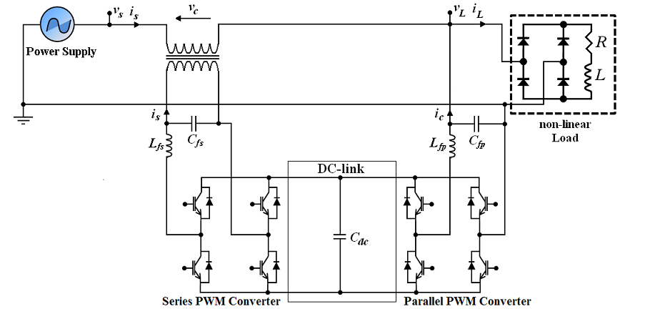
DESIGNG SOFTWARE AND TOOLS:
MATLAB /SIMULATION Software and simpower systems tools are used. Mainly control system tools, power electronics and electrical elements tools are used.

